**Income Inequality Homework 1**

Ross Lewis, Qian Li

Introduction

We studied the changes in relative supply, demand, and wages of works with to without STEM degrees from 2009 to 2017. Although our results were not statistically significant, we found a general trend of demand for STEM employees falling over this period while supply increased. As a result, our fit for the pay gap of a STEM degree fell slightly over this period. Additionally, we analyzed the change in wage share over this period and found that of the increase of 1.276% the STEM majors gained in wage share, the between industry effect was -.036% and the within industry effect was 1.313%.

Canonical Model Analysis

After cleaning the data, we fit a linear regression model using supply and time on the STEM wage premium:

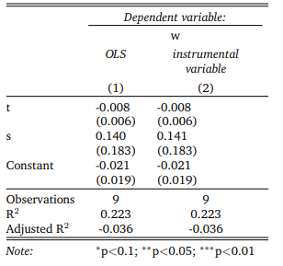

Our results were not statistically significant, but they do tell us a little bit about the data. We see that, on average, as time passed from 2008 to 2017, demand for STEM workers fell by .8% per year. Additionally and counterintuitively, our coefficient for relative supply is positive, implying that for some years, an increase supply shock could coincide with an increase in the wage gap. That being said, our standard error was greater than our beta, so we shouldn’t draw any conclusions from this result.

Next, we visualized our data to have a better understanding of the wage gap and supply of STEM workers. There was a large increase in STEM labor from 2009 to 2010, with small fluctuations following:

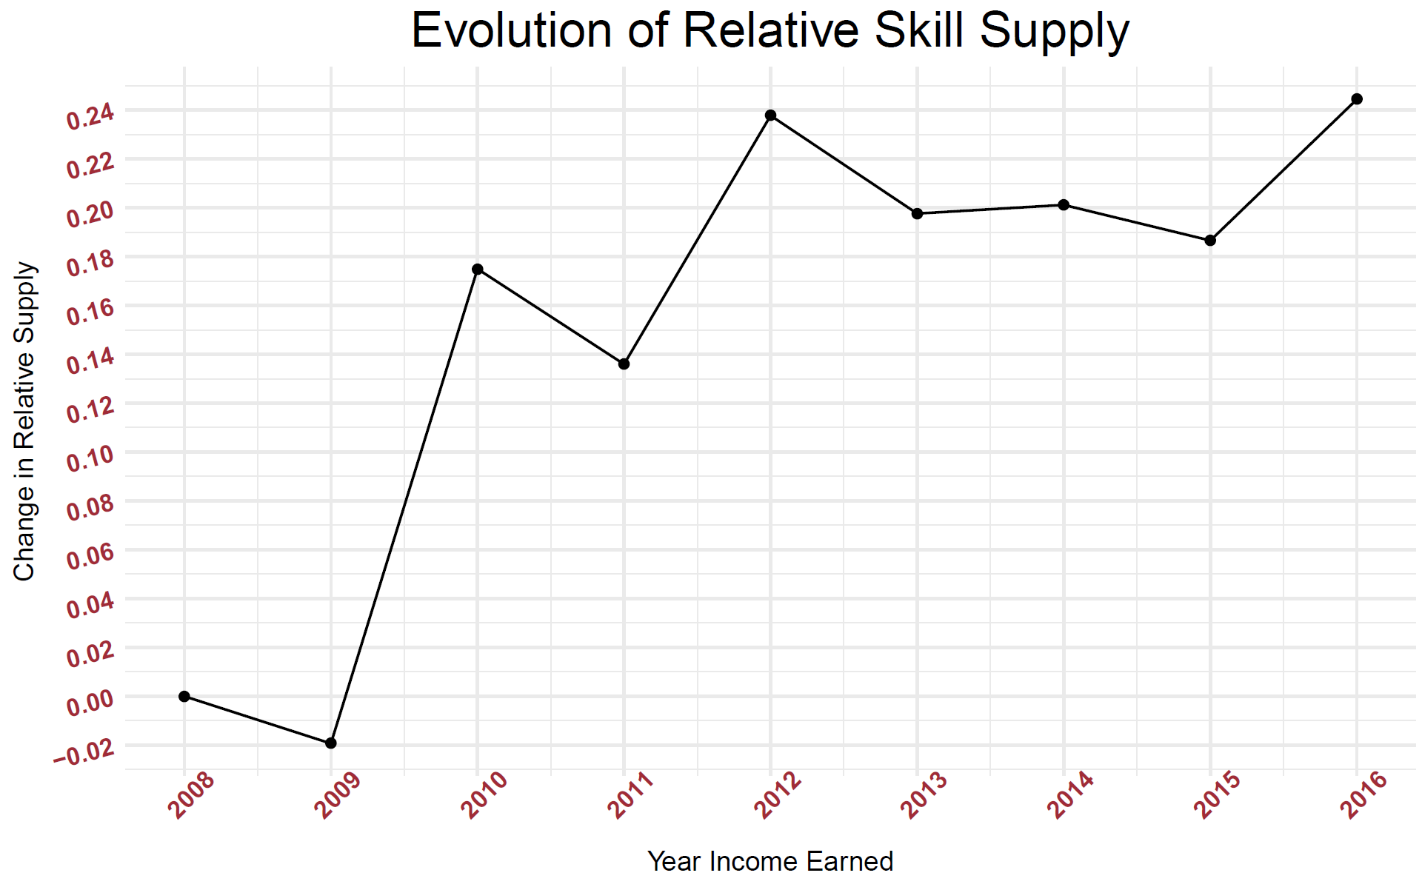

This might explain why our regression was unreliable. We can compare this to the wage gap:

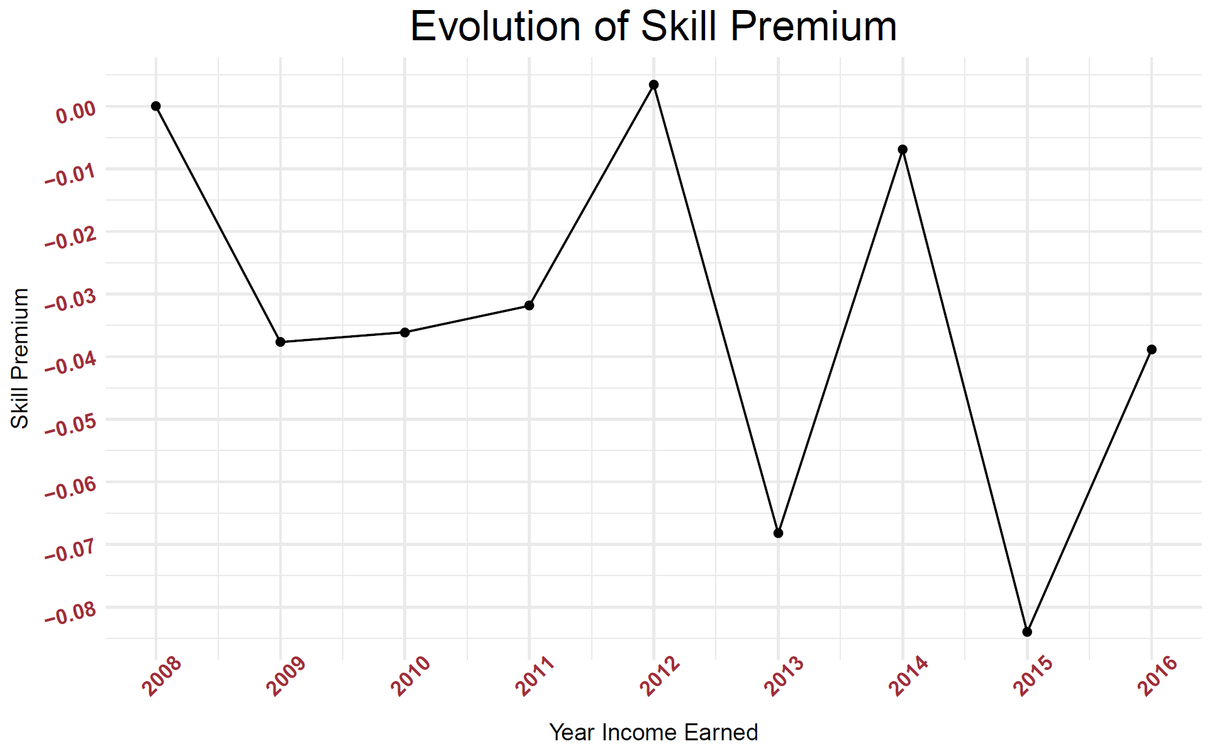

If supply were the only determining factor, we might intuitively consider that (on average) relative supply increased during this time and the overall STEM premium fell. However, we also need to consider demand. Our regression fit shows us that over time, demand was pulling the premium down while supply factors tended to bump up the gap:

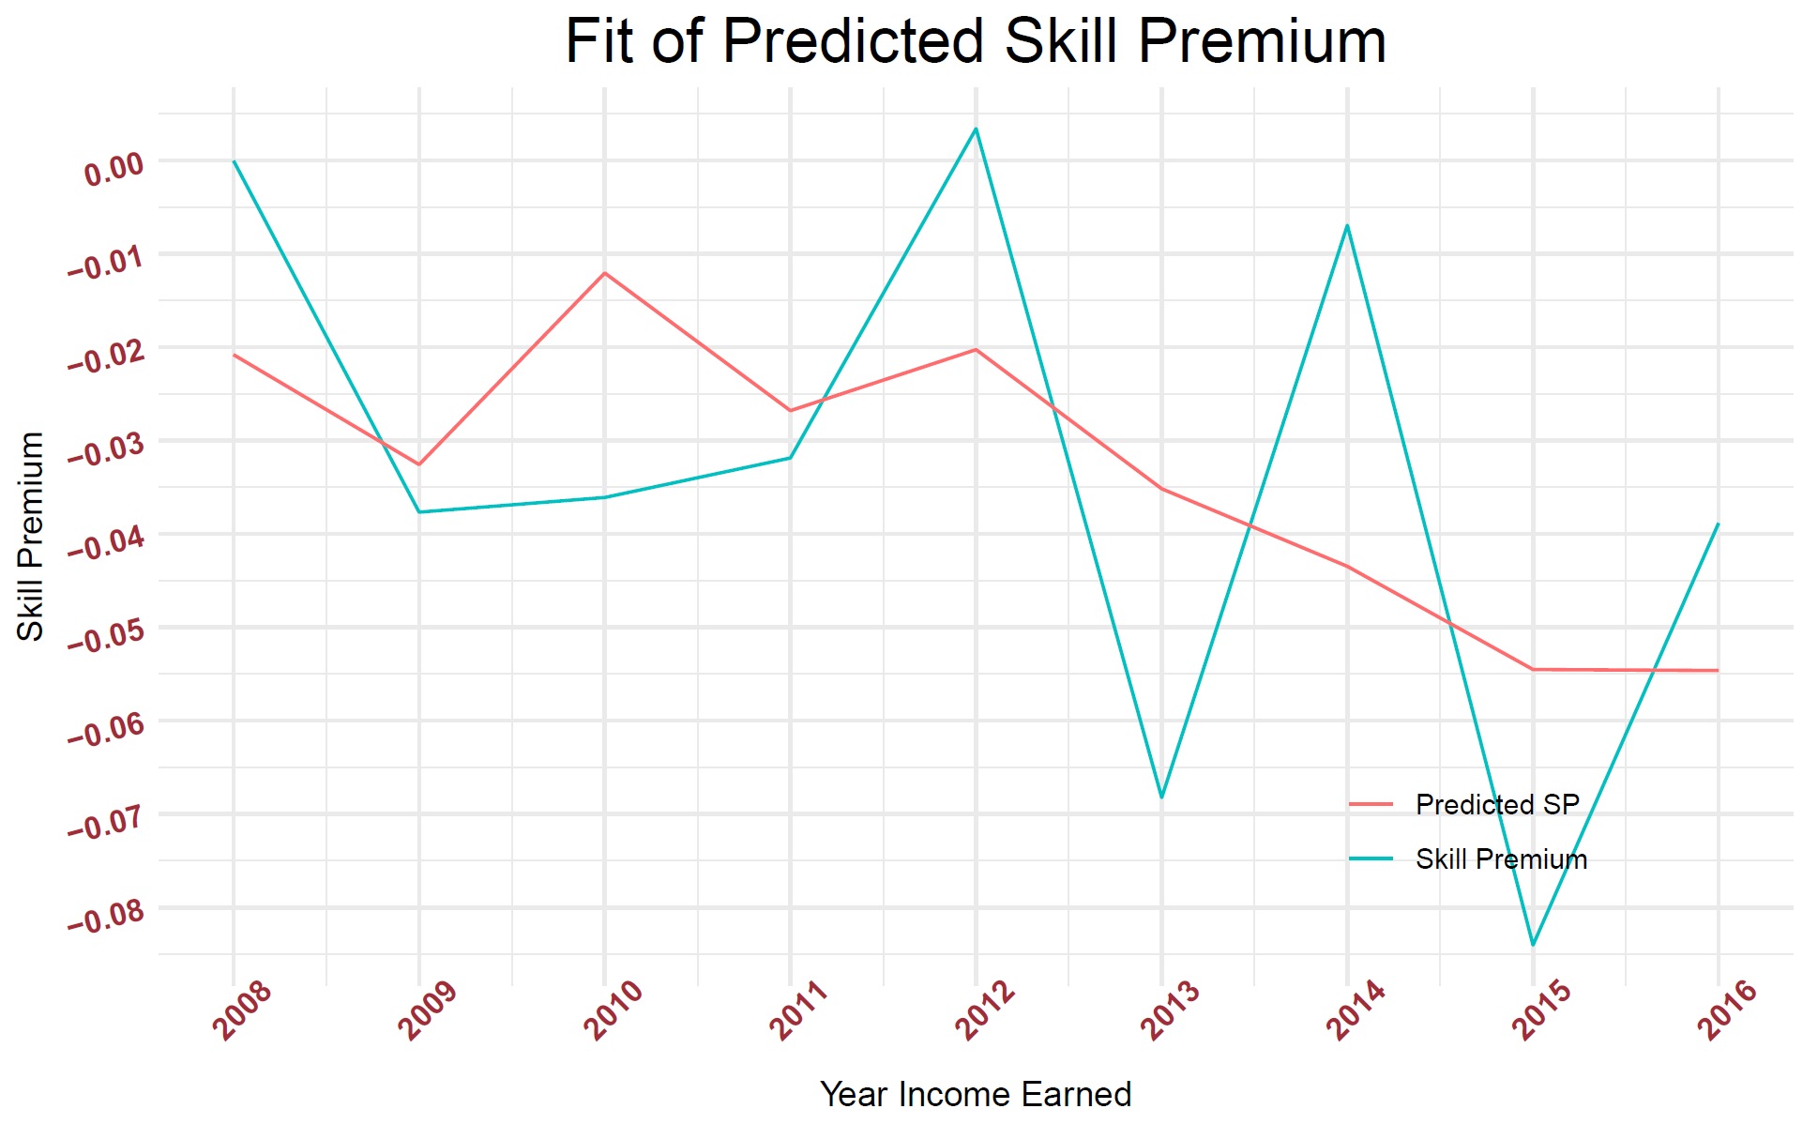

Finally, we conducted a shift share analysis on the different industries to find if the gap over time was due to more industries becoming (less) STEM focused, or changes in the industries that were saturated with STEM employees. We found that there was only a 1.276% change in wage share over this time. This also seems counterintuitive, but it can be explained by the change in real wages. Even though the gap lessened over time, more workers might be in STEM at the end of the analysis, making their wage share larger.

Shift-Share analysis

The between industry factor accounted for -.036% of the change, and the within industry changes accounted for 1.31%. This means that STEM majors received more of the income in all industries, not just the STEM intense fields.

We have shown that there has been a general downward trend over time for demand of STEM labor, but an increase supply. This has led to some sporadic movements in the STEM wage gap premium, but it could not be explained only by the canonical model with supply and demand. We also found that the 1.31% increase in income share that went to STEM majors from 2008-1016 was due mostly to all industries placing more value on STEM majors.

Appendix

To begin with, we marked each person as STEM or non-STEM. We utilized the “Stem Degree List” (<http://stemdegreelist.com/stem-degree-list/>) to find which degrees in the USA Ipums data set could be classified as Science, Technology, Engineering, and Math. One outlier to take note of that would work against a positive STEM gap is Law, which we classify as non-STEM.